**EC2 AMI (Amazon Machine Image)**

-> EC2 (Elastic Cloud Computing)

-> using EC2 we can create virtual machines in AWS Cloud

EC2 instance = virtual machine/Instance/Server/node

->EC2 having several AMIs (Amazon Machine Image)

-> AMI means Pre-Configured Machine. EC2 is giving several AMIs to launch Virtual Machines quickly

(AWS is giving you readymade machines i.e called as AMIs) ex: Linux, Ubuntu, Red-hat, Amazon-Linux, Microsoft-windows...

Note: for example for SBIProject I have taken a Linux machine, in that machine I have installed Jenkins, Webserver, SonarQube Softwares so now all my environment is ready to run that application. So in order to configure this it took 4hours time to setup all the Softwares required for project

so now tomorrow I got another project ICICI so again I need to setup machine like this only, again I need to spend 4hours time, if I get 1 more project again I need to spend 4 hours of time

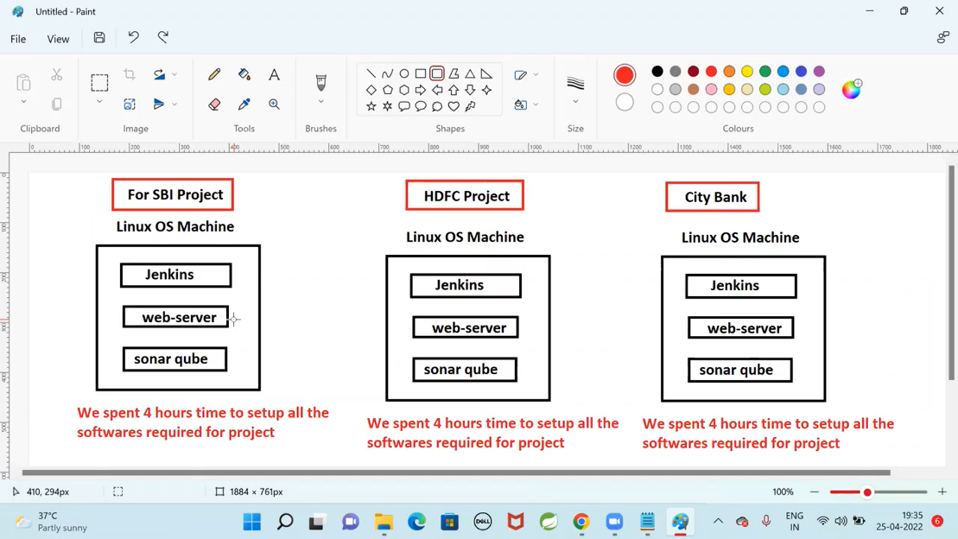

We can avoid the same tasks again & again by using Images

so Once we have created a Linux machine and installed all the Softwares then we can create this machine as a Image… so next time for any project if u need the same kind of machine u can use the image and u can create within a minute

Using EC2 AMIs we can launch Virtual Machines easily so my own image I can create EC2 instance

So In AWS we can create our own Images also

**Procedure to create own image**

1. Go to EC2 Dashboard
2. Select EC1 instance
3. Click on Action -> select image -> create image -> Give unique name for image

Note: This will create our Own Image in AWS

Note: Images are Regional Specific

Other people also can use our own create image

Note: When we are working on multiple projects then we can use Images to setup virtual machines easily ( no need to do setup for every project, create a VM for that VM u create a image and for next project u use that image then u can setup the machine directly)

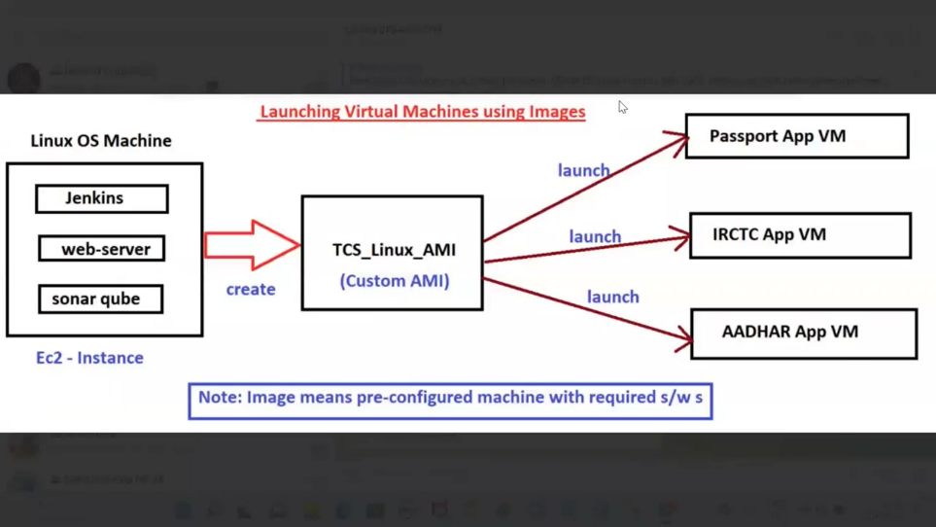

So the Main advantage of Creating Image is, using this image I can launch 100s of multiple VMs within minutes

So launching VM using images is going to save our time quickly we can setup the VMs with required Softwares, no need to do the same work again and again

Ques: Now do I need to install softwares like Jenkins, SonarQube, webservers in passport App VM, in IRCTC App VM, in Aadhar App VM ?

Ans: No they will come along with the VM

**EC2 InstanceTypes**

In EC2 we have several Instance types

1. On Demand Instances: means when u want instance u can create it…

-These are Fixed Price min billing period is hourly and if u run the instance for 5 mins also they will consider as 1houly only

-These instances are PayForWhatYouUse.

-No commitment (u create the instance and u terminate the instance)

- No upfront Payments (no need to pay first only... first u use it then u pay the money)

2. Reserved Instances: means u are going to purchase the reserved instances for min 1year r max3years

We are going to reserve the instance for our requirement

3. Spot Instances:

4. Dedicated Host Instances: